Project Proposal

Digital Logic Design Lab


Project Title

Automated Traffic Light Control System

Group Members
- 25P-0005 Waleeja Khan
- 25P-0011 Muhammad Awais

ABSTRACT:
This lab project involves designing and implementing a low cost, and automated Traffic Light Control System to simulate real world traffic light sequence, using different logic components. The project operates by a 555 Timer IC to generate a clock pulse and CD4017, a decade counter, to manage the timely switching of traffic signals. The 555 timer IC operates to generate a continuous clock pulse, which activates the CD4017 to cycle through its outputs. The project will ensure traffic safety, and it will serve as an effective demonstration of digital counting and basic electronic logic. The design will be verified on some software such as Multisim before implementing it on hardware.
OBJECTIVE:
The Automated Traffic Light Control System aims to design a hardware-based traffic light controller using distinct integrated circuits.
METHODOLODY:
The project works by using simple digital logic components like IC’s instead of using big programmable logics.
The 555 Timer works as a clock, continuously sending electrical pulses. The speed of the pulses is controlled by resistors and capacitors.
These pulses travel to CD4017, a decade counter having 10 outputs (counts from 0 to 9). Every time it receives a pulse from the timer, it turns OFF the current pin and turns ON the next pin.
As we know, a real traffic light needs Red and Green to stay on longer than Yellow. So instead of having every light stay on for the same amount of time, we use diodes to group the counts together. We wired four counts to Red and Green, but only one to Yellow, due to which the red and green lights stay ON much longer, perfectly showing how a real-world traffic signal works.
The circuit works in a continuous loop Red for a long count (Stop), Yellow for a little count (Prepare), Green for a long count (Go). A tiny pause, and then it starts all over again from red.
Multisim Implementation:

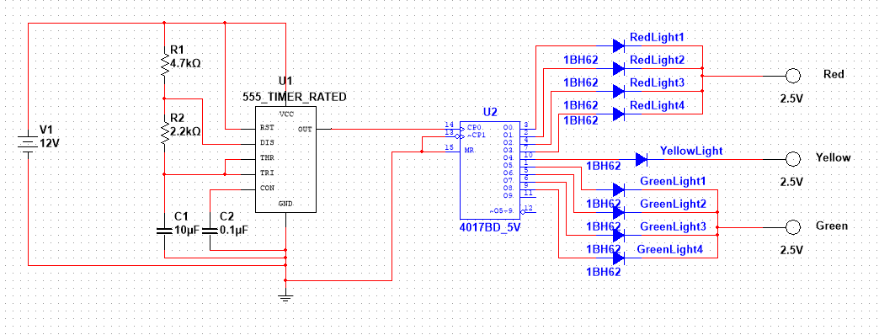

COMPONENTS:
- INTEGRATED CIRCUITS:
- NE555 Timer IC
- CD4017 Decade Counter
- DIODES:
- 1BH62 Signal Diode
- RESISTORS:
- 4.7k Ω
- 2.2k Ω
- CAPACITOR:
- 10μF
- 0.1μF
- INDICATORS (Probes)
- POWER & PROTOTYPING:
- Solderless Breadboard
- 12V DC Battery

